Mikey Replan | Creative Prototyping HW | 10/08/24

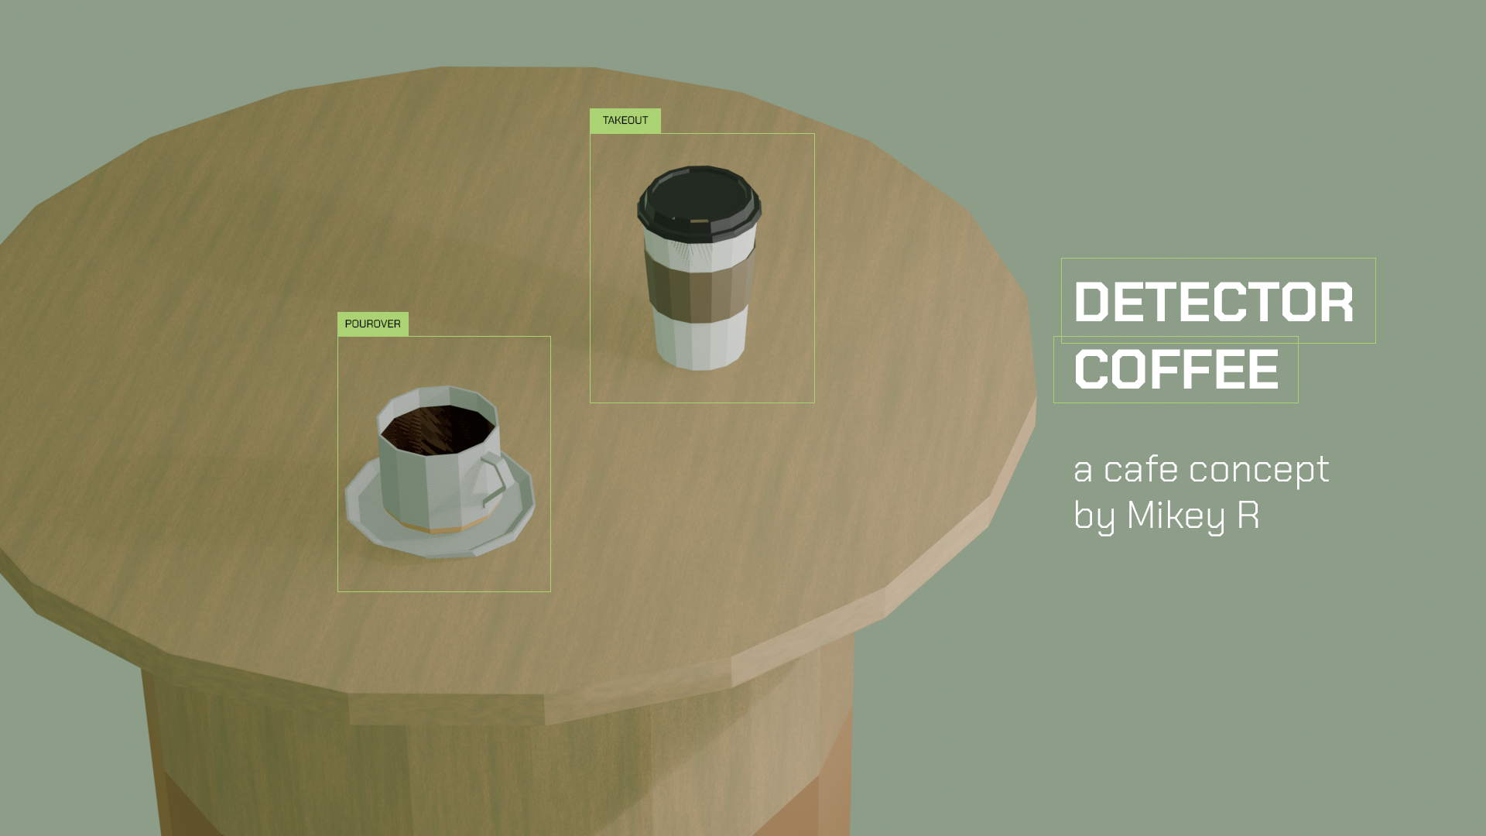

Figure 1: Final render! Text and bounding boxes were added with Adobe Photoshop to create a cafe ad.

# Ideation

## ☕️That’s that me espresso🎶

Coffee has always been a source of creativity! I used this homework as an opportunity to make a fun low poly render ad for an imaginary coffee shop. I felt inspired by minimal café designs that is ubiquitous in Los Angeles. Minimalist ceramics and other items conveniently prompted me to attempt to make those items. Also, during brainstorming, a lot of my coffee wares were within my line of sight. It was destiny.

## 📷Look at this photograph🎶

A lot of these cafes use Kinto brand products. Kinto does a great job with product photography so I got some good angles of one of my favorite ceramic mugs, the CLK-151 ceramic dual tone mug. The simplicity of these mugs as well as the innate simplicity of the furniture used in the photoshoots is a good starting point to my Blender career. I also thought it would be fun to create a takeout cup which adds some complexity. The 3 items to create is the **mug, saucer, and takeout cup.** For bonus, I wanted a nice **birch table** for the low poly photoshoot. Photos below captured the geometry well and provided mood!

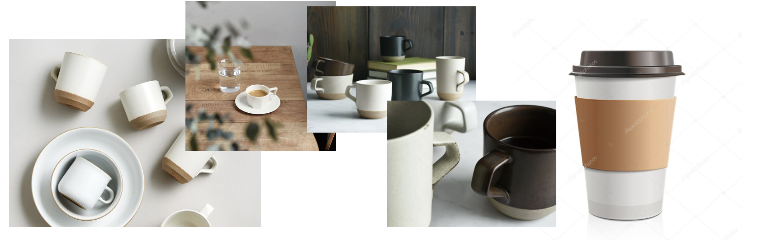

Approach

## 🎶Get by with a little help with some friends🎶

Running YouTube on the side, looking for similar-shaped tutorials for beginners was super helpful. There were tons of resources, some good, some bad, but once I found one that did a good job providing commentary on choices and shortcuts, it was great!

## 🤖We are the explorers🚀

…but one of the more fun ways I like to learn was simply explore the tool! I let my curiosity go wild, exploring the different menus, random hitting keyboard keys, playing with the knobs and noting the consequences of turning that said knob too far. Thank goodness for undo history! Although Blender looks very intimidating with the many buttons and panels, this activity helped me identify the essential tools and potential menus to explore later.

## ⚾️We’re going back to work on fundamentals

When I look at my 3 objective items, I like to identify the fundamental Blender object that would closely reach that final item form – for all three, due to it being radially symmetrical, I knew the Cylinder object would be a great way to start!

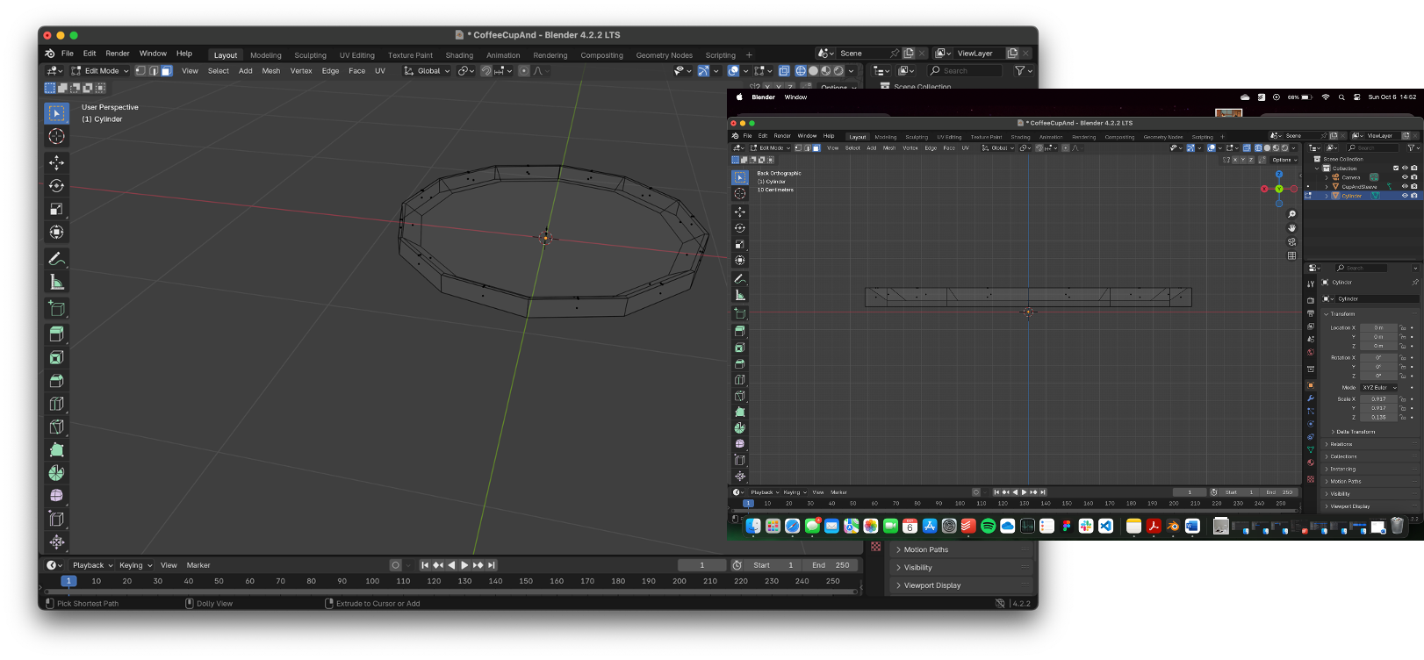

Figure 2: In this example, I recognized the Kinto saucer/plate to simply be a flattened cylinder. I utilized inward scaling and extrusion to create a nice "valley" where the cup would consequently stand upon.

## Bevel, let’s be friends 👯

When I was making the tapered ceramic bottom of the takeout cup and the Kinto CLK-151, I was performing multiple “ring edge” radial scaling and translations to get a low poly taper effect. I realized that there was a button that achieved a similar thing… Bevel! Learning bevel was handy and streamlined my workflow …while also realizing there’s so many ways to tackle this.

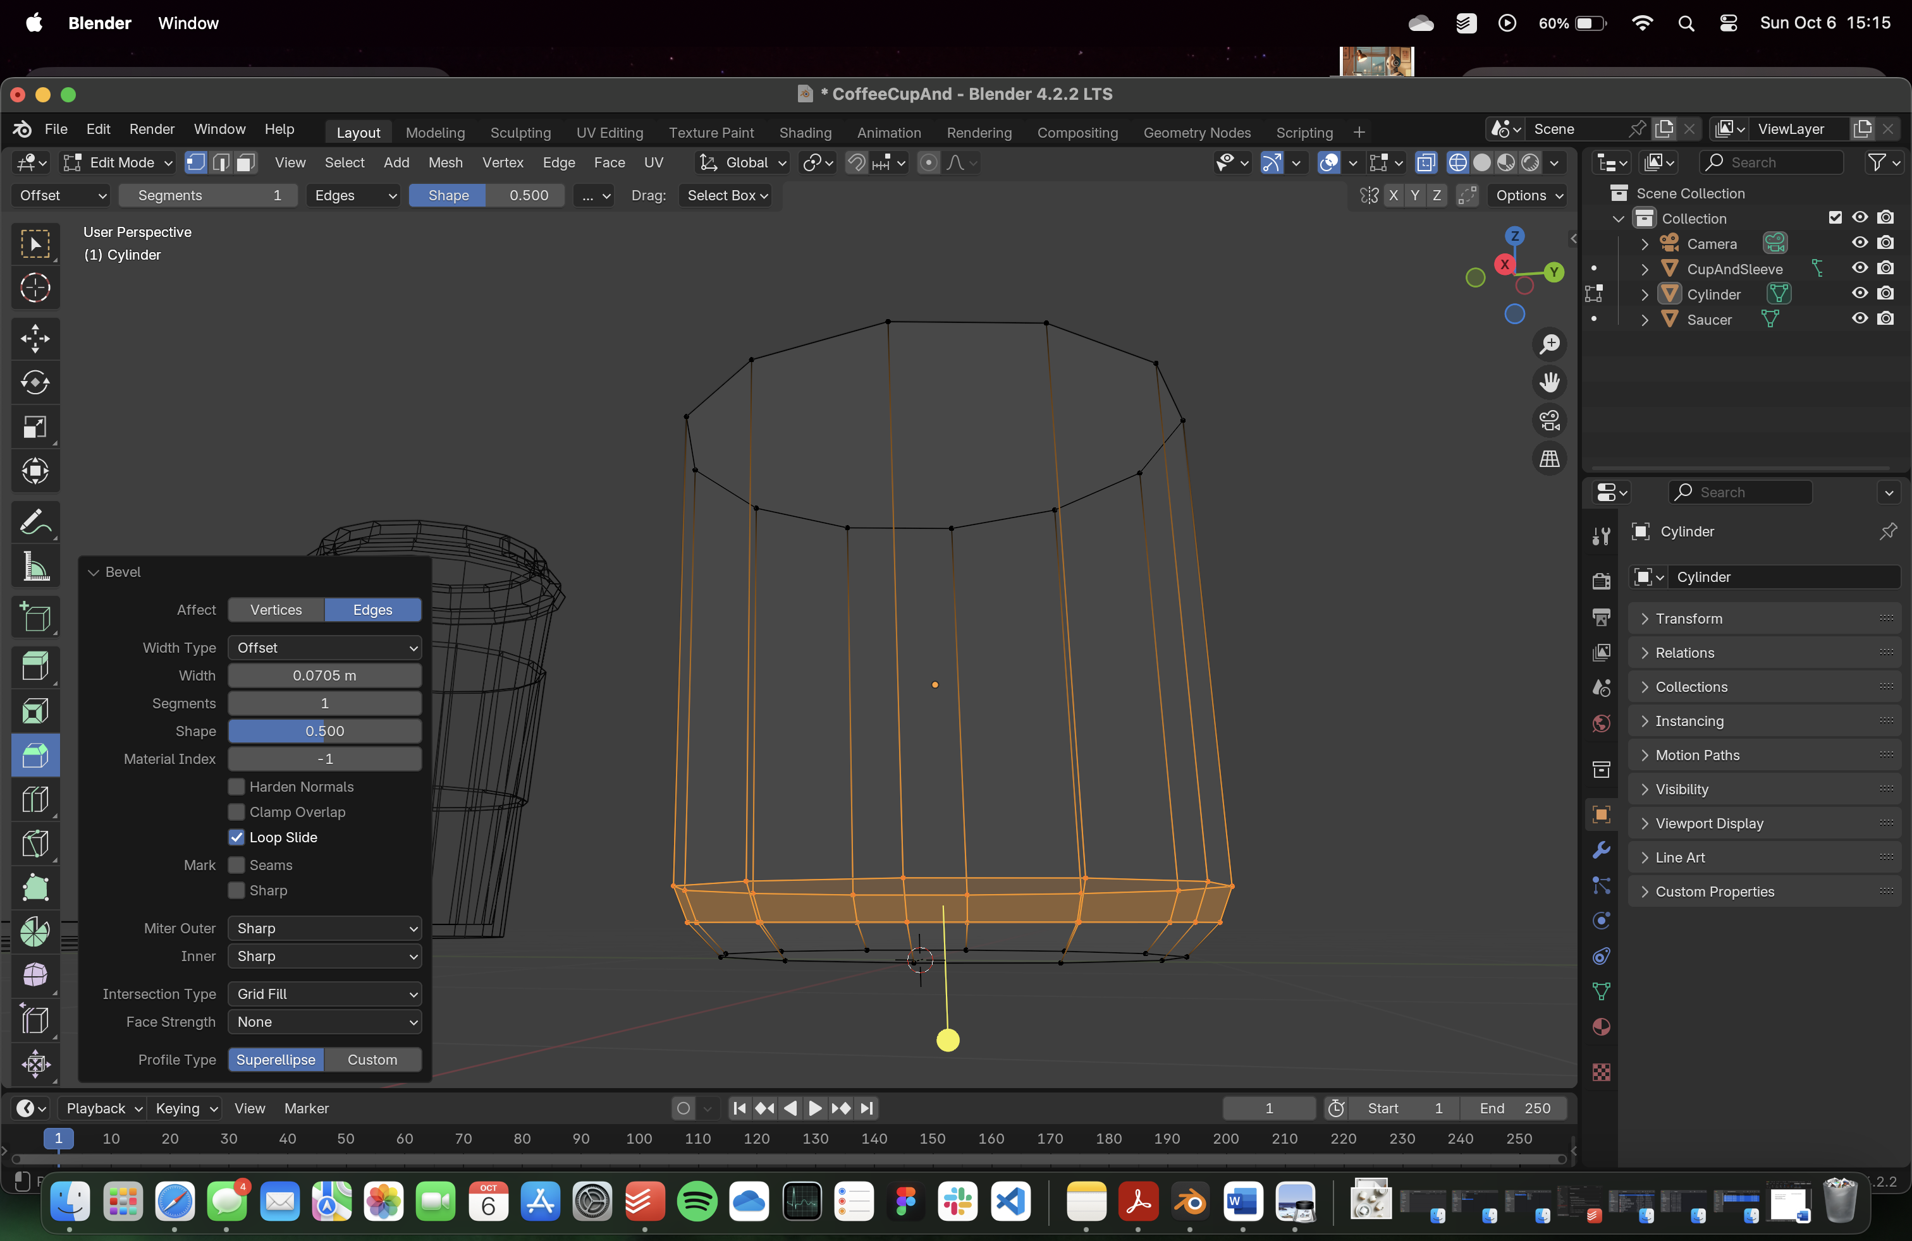

Figure 3: Bevel helped me achieve the low poly taper effect that forms the contrast ceramic bottom of the Kinto mug!

## ☕️Can You ~~Dig~~ Handle It?

Kinto CLK-151 had a unique handle design, it had a particular “angular” design to it that cannot be achieved by the default Blender shapes. My first thought was associate the handle shape to be akin to half a thin donut, which could be feasible for more simple handle designs, but instead I thought of this component to utilize extrusion of a small rectangular piece and “trace” out the handle! The reference photos, especially side-profile came very handy here!

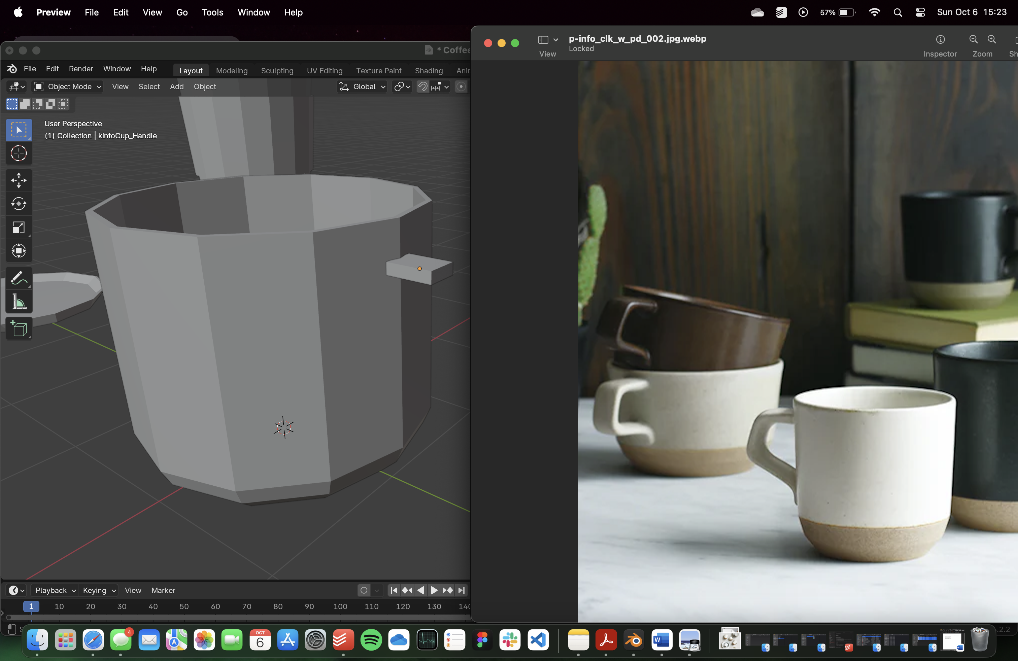

Figure 4: With the side-profile reference photo, I confidently started my rectangular extrusion. I rotated the leading extrusion face to "trace" out the angular curves of this unique handle.

## ⛳️He’s fixing a divot!

The takeout cup featured a plastic lid that has lipped rim, drinking hole and “crater” at the top of the lid. I refer to the crater as a “divot”. Before I discovered the bevel option, I formed the lid utilizing repeated use of radial scaling and translating the vertices along the z-axis (vertical, g+z). These 2 actions allowed me to form the sloped sides of the lid towards the divot and was also used for the takeout cup as well. The takeout cup sleeved simply involved creating new vertices on the central body of the cup and ever so 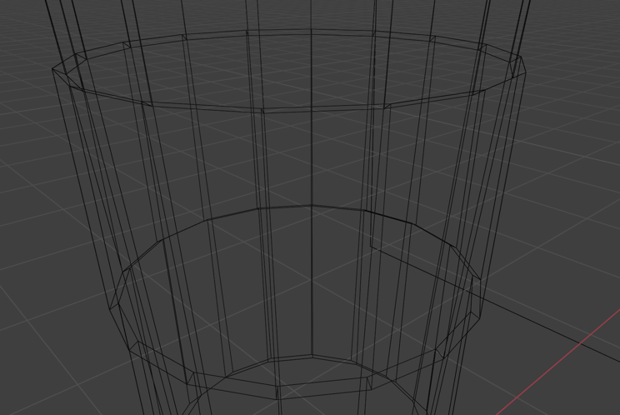slightly expanding those surfaces radially outward, paper thin!

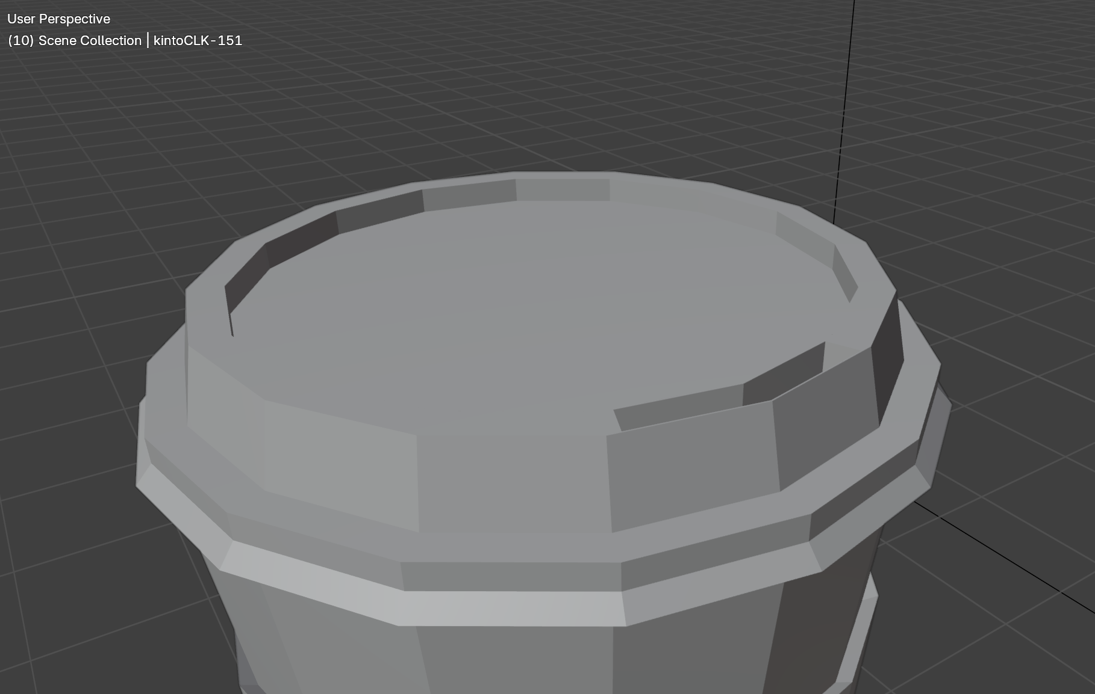

Figure 5: Closeup of the takeout cup lid that features the rimmed lip, sipping hole, and shallow "divot" in the center. On the right is a wireframe showing the paper sleeve around the takeout cup central body.

## 🎤We are living in a material world, and I am a material girl

Once all items were generated (table was the easiest, it consists of a flattened cylinder and large stump-like cylinder) it was time to treat the surfaces! During my YouTube tutorial binge, I came across a very quick beginner tips TikTok that recommended to explore a myriad of add-ons that the author wished they knew about – one add-on that helped me as the Material VX add-on. This extension provided me a handful of preset materials to explore – some did not make any absolute sense but 2 of them did: “wood” and “cranberry juice”.

* The latter material prompted me to create a quick shape to fill the Kinto cup with a liquid – this was done by cloning the bottom of the cup and extrude it upwards with some headroom, that will be my coffee! I modified the “cranberry juice” material preset’s surface color to a referenced coffee-colored hex code.
* I applied the wood material to the table – I immediately was appalled at the wood color, it was this dark antique-colored wood that didn’t really match the design language of Kinto. Further, since this was a low-poly look, the realistic looking colors did not really match the simplicity of the low poly objects. I noticed that this coloring is driven by the selection of parameter Color2 and Color1 for this material. I selected light birch color hex codes that were ever so slightly different in luminosity value, which matched Kinto’s branding (which also matches my favorite brand, Muji).

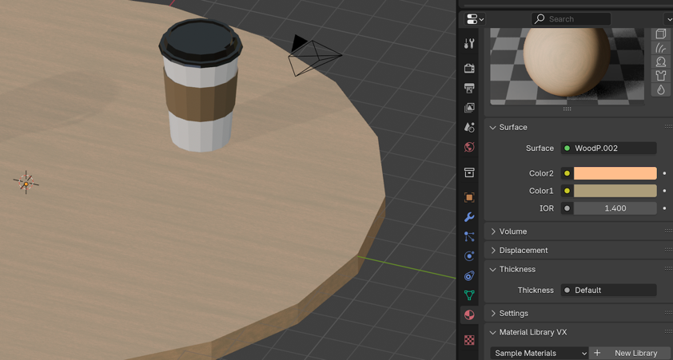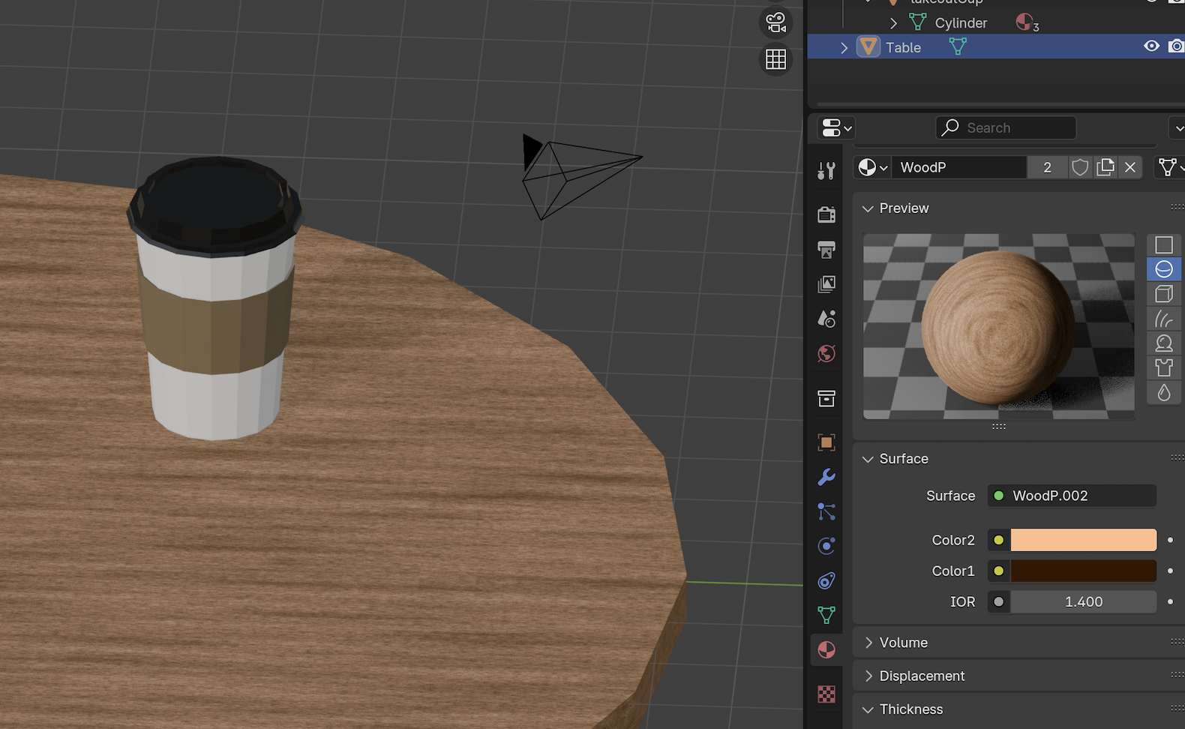

Figure 6: Default wood color was too realistic and antique looking. By selecting lighter, birch color pairs, it makes the wood grain less noticeable and more appropriate for what I was looking for - minimalist, raw material.

📷Mom get the camera!!!  
With surfaces selected for the objects, I created a light panel shining on the side of the tableside – I picked side-lighting to simulate the low angle sunlight that’s associated with the crack-of-dawn. The sizing of the light source made the light diffuse and soft to achieve the “quiet morning” vibes of Kinto brand.

The camera was finicky at first until I changed a key preference that was recommended by a lot of Blender Tutorial YouTubers – locking the camera view to my view. This made it so much easier to frame the shot because it’s a lot more intuitive compared to translating the camera object itself. When I framed the image, I wanted to capture how the light forms darker and lighter facets on the objects as well as show the dark shadow of the table’s support structure. Further, I selected a wide aspect ratio with lots of negative space so I could add text later on to create a café concept ad. For background, I selected the world color to be soft pastel matcha hexcode that maintained the “quiet morning vibe”.

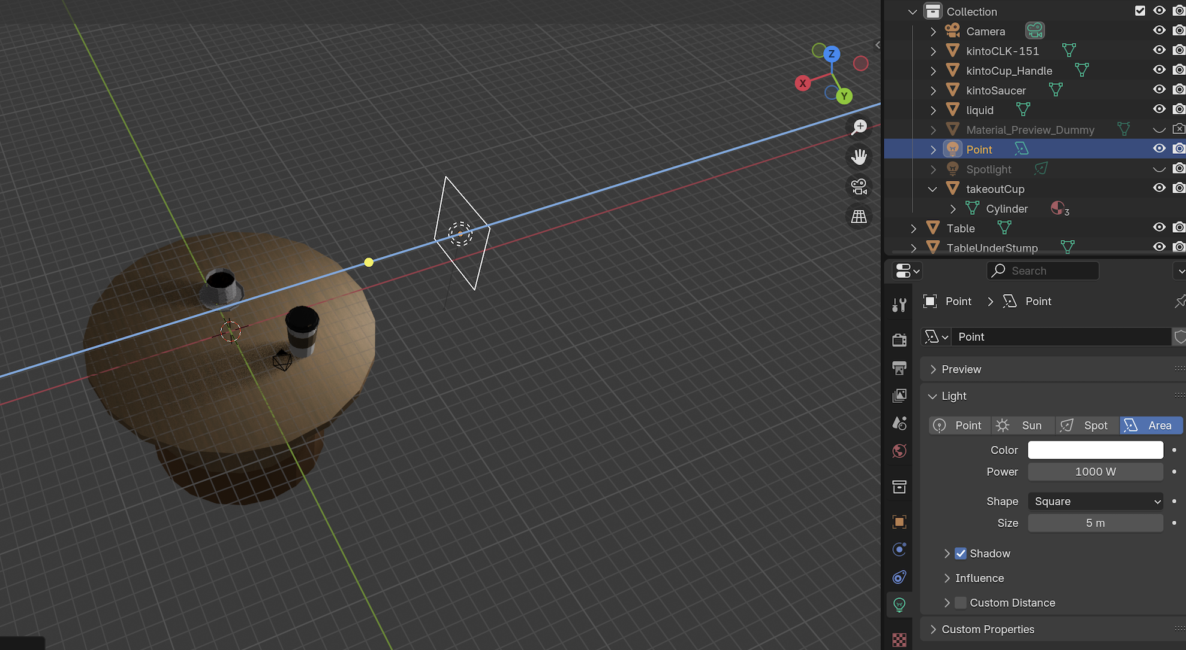

Figure 7: Setting up the simple, side-panel lighting! I used to do studio photography, so this is akin to setting a large diffused LED panel on the side for product shoots!

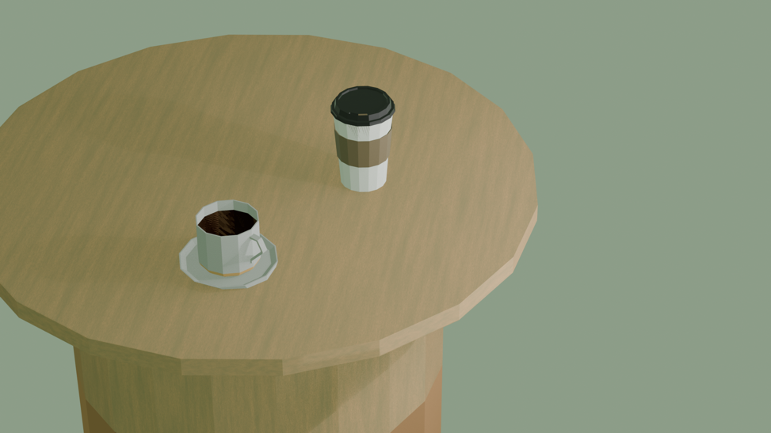

Figure 8: Final render! EVEE was most appropriate for speed and simplicity. I really like the gentle shadow-play and simple background color. This reminded me of my favorite low poly game, Katamari Damacy.

And there you have it! This activity helped me gently take on Blender. These objects, takeout cup, Kinto cup, Kinto saucer and table exercised many essential “sculpting” transformations! In the next section, I noted many several personal lessons-learned that will continuously improve my Blender journey!

# Lessons Learned

* **Save early, save often:** I realized this application does not have the luxury of autosave. Which makes sense because of the so many actions per minute. My other tools in my tech stack have autosave, such as Figma, so it was a notable habit I needed to form for Blender.
* **Plug it in, plug it in:** I realized my Macbook Pro wasn’t plugged into an outlet which meant I could have lost a lot of data if my laptop suddenly shut down. Further, I believe full utilization of processing power is enabled when plugged in, which benefits Blender greatly.
* **Peripherals = QOL:** I had to connect my mouse, numpad and external monitor. Those helped a lot immensely and made my productivity significantly better. I could have google, guides, references and hexcode lookups on the side while my main screen was focused on blender.
* **Welcome to TikTok Era:** for some reason, a lot of tutorials are 30-second TikTok format pro-tips that are insanely hard to follow because of sped up speech and unexplained use of power-user shortcuts. Those didn’t make sense until I knew the shortcut!
* **Organize along the way!**: Even for such a simple scene, there were lots of objects/items to manage! I learned about using “collections” to make things more manageable. By grouping objects, such as the Kinto cup handle, cup and saucer, I can not only make it easier to hide by enabling the collection visibility on/off, but also when repositioning the set of objects on the table.

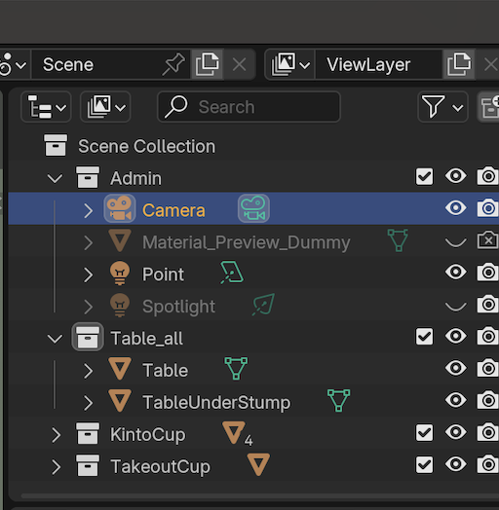

Figure 9: Grouping my objects in different collection "boxes" helped me arrange the object sets a lot more efficiently!